**DAILY ONLINE ACTIVITIES SUMMARY**

|  |  |  |  |  |  |  |  |  |
| --- | --- | --- | --- | --- | --- | --- | --- | --- |
| **Date:** | **10/06/2020** | | | | | **Name:** | **Katira Krishna J** | |
| **Sem & Sec** | **8th A** | | | | | **USN:** | **4AL16CS045** | |
| **Online Test Summary** | | | | | | | | |
| **Subject** | | **-** | | | | | | |
| **Max. Marks** | | **-** | | **Score** | | | **-** | |
| **Certification Course Summary** | | | | | | | | |
| **Course** | **Introduction to Data Science** | | | | | | | |
| **Certificate Provider** | | | **Cognitiveclass.ai** | | **Duration** | | | **3 hours** |
| **Coding Challenges** | | | | | | | | |
| **Problem Statement: Python program to check common letters in two input strings** | | | | | | | | |
| **Status: Completed** | | | | | | | | |
| **Uploaded the report in Github** | | | | | **yes** | | | |
| **If yes Repository name** | | | | | **Krishna_Katira** | | | |
| **Uploaded the report in slack** | | | | | **yes** | | | |

Online Test Details:

NOT CONDUCTED

Certification Course Details:

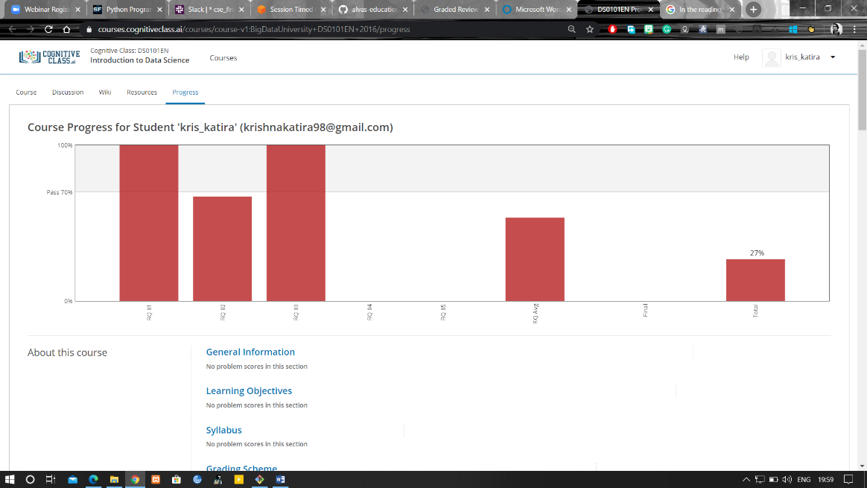

Coding Challenges Details:

**Program:**

s1=raw_input("Enter first string:")

s2=raw_input("Enter second string:")

a=list(set(s1)&set(s2))

print("The common letters are:")

for i in a:

print(i)